SQL Assignments - Set 3

The below 10 questions are based on the Emp table:

- Display the average, lowest, highest and difference in lowest and highest salaries for each department number.

Select Deptno,
Avg(Sal) as "Average Salary",
Min(Sal) as "Minimum Salary",
Max(Sal) as "Maximum Salary",
Max(Sal)-Min(Sal) as "Difference"
From
Emp
Group By Deptno;

- Display the number of employees within each job.

Select Job,
Count(Job) as "Number_Of_Employees"
From Emp
Group By Job;

- Display the lowest salaries job-wise within each department number.

Select Deptno,
Job,
Min(Sal)
From Emp
Group By Deptno,Job
Order By 1,2;

- Display only those jobs where the minimum salary is greater than or equal to 3000.

Select Job,
Min(Sal) As "Min_Salary"
From Emp
Group By Job
Having Min(Sal) >= 3000;

- Display the records sorted as per the job. Make sure that within each job the records are sorted as per the highest to lowest salaries.

Select *
From Emp
Order By Job, Sal Desc;

- Display Deptno, total of that deptno and Grade. Grade should be A if the total is greater than 10000, else it should be B. Sort the summary output as per the highest to lowest Grade.

Select Deptno,
Sum(Sal) as "Total",
Case
When
(Sum(Sal) > 10000) Then 'A'
Else
'B'
End as Grade
From Emp
Group By Deptno
Order By Grade Desc;

- Calculate and display only the average salaries paid to all those employees where the employee name starts with A and name starts with S.

Select Round(Avg(Sal)) As "Average Sal"
From Emp
Where Ename Like 'A%' Or Ename Like 'S%';

- Product exactly same output as shown below:

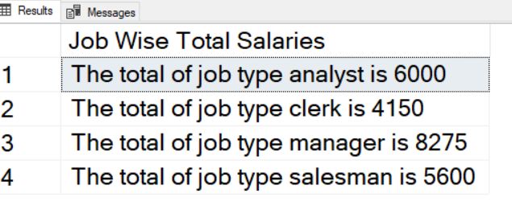
Select Concat( "The total of job type ", Lower(Substring(Job,1)), " is ", Sum(sal)) as "Job Wise Total Salaries"
From Emp
Where Job != 'President'
Group By Job
Order By Job;

- Display Mgr code and number of sub ordinates reporting to them for only those managers who have at least 3 sub ordinates.

Select Mgr,
Count(Mgr) as "Number Of Sub-Ordinates"
From Emp
Group By Mgr
Having Count(Mgr)>=3;

- Product exactly same output as shown below:
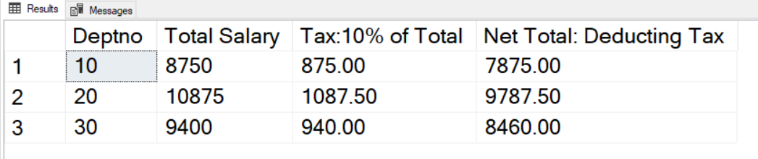

Select Deptno,
Sum(Sal) As "Total Salary",
Sum(Sal)*0.1 As "Tax:10% of Total",
Sum(Sal)-Sum(Sal)*0.1 As "Net Total:Deducting Tax"
From Emp
Group By DeptNo
Order By DeptNo;

The below 10 questions are based on the Products2 table:

- Display the Highest sales for each product within a country for each continent.

Select Continent,
Country,
Pname,
Max(Sales) as "Highest Sales"
From Products2
Group By Continent,Country,Pname;

- Display the average sales for each product region-type wise within each area for each country.

Select Country,
Area,
Region_type,
Pname,
Avg(Sales) as "Average Sales"
From Products2
Group By Country,Area,Region_Type,Pname;

- Display the country-wise number of products for each product

Select Country,
count(Pname) As "Number Of Products"
From Products2
Group By Country;

- Display the Country wise total of sales for each Continent. The summary records should be shown as per highest to lowest sequence of totals. But in the final display only first 2 records should be shown.

Select Continent,
Country,
Sum(Sales) As "Total"
From Products2
Group By Continent,Country
Order By Total Desc
Limit 2;

- Display the exact following report:

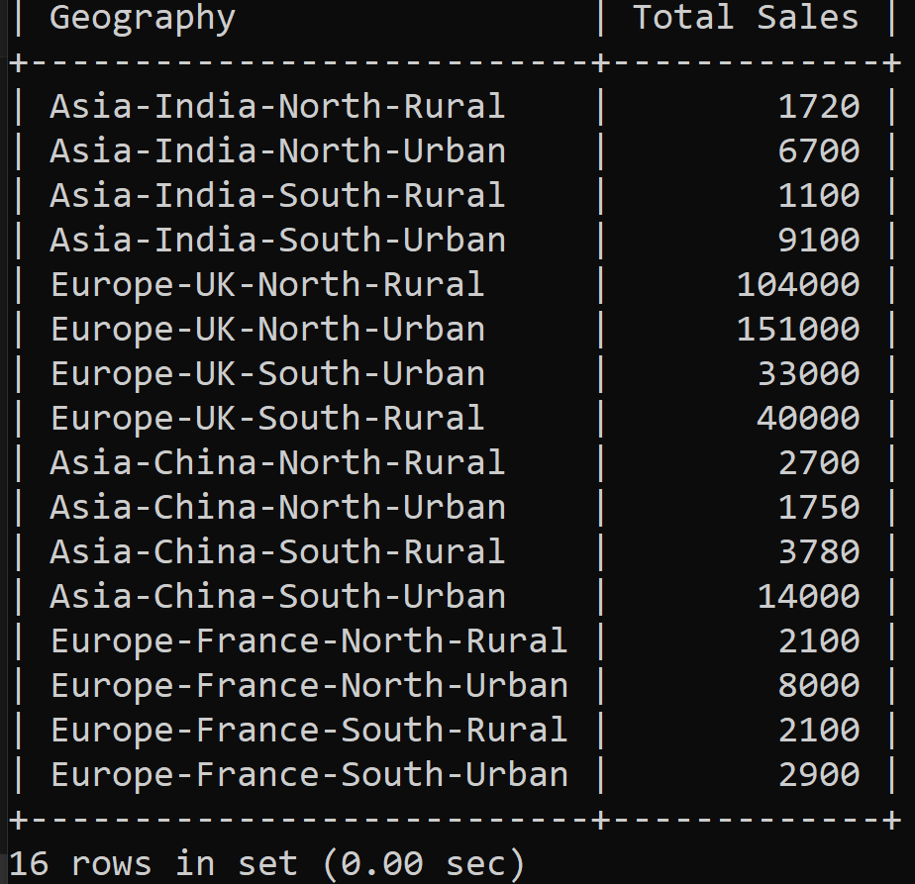

Select Concat_Ws("-", Continent, Country, Area, Region_Type) As "Geography",
Sum(Sales) As "Total Sales"
From Products2
Group By Continent, Country, Area, Region_Type;

- Display the product name wise total sales excluding records of Rural region of North area.

Select Pname,
Sum(Sales) As "Total Sales"
From Products2
Where Area <> 'North'
And
Region_Type <> 'Rural'
Group By Pname;

- Display country wise average sales excluding country India

Select Country,
Avg(Sales) As "Average_Sales"
From Products2
Where Country <> 'India'
Group By Country;

- Display product name wise total sales for all the transactions done from transaction id 23 onwards.

Select Pname,
Sum(Sales) As "Total Sales"
From Products2
Where Trans_Id >22
Group By Pname;

- Display Country wise count of transactions done.

Select Country,
Count(Trans_Id) As "Number_Of_Transactions"
From Products2
Group By Country;

- Display Country wise average sales done of Samsung only.

Select Country,
Avg(Sales) As "Average_Sales"
From Products2
Where Pname = 'Samsung'
Group By Country;

The below 2 questions are based on the India table:

- Display product name wise count of records from India table.

Select Pname,
Count(Qty) as "Total_Quantity"
From India
Group By Pname;

- Display product name wise total of quantity for the transactions having quantity above 1.

Select Pname,
Sum(Qty) as "Total_Quantity"
From India
Where Qty > 1
Group By Pname;

The below 3 questions are based on the Code_Data table:

- Display the total amount as per code which will be grouped by 3rd, 4th, 5th and 6th characters of code column’s values.

SELECT
SUBSTRING(code, 3, 4) AS Code_Group,
SUM(amount) AS Total_Amount
FROM
Code_Data
GROUP BY
SUBSTRING(code, 3, 4);

- The last 4 digits of code values represent the year. Display year wise total amount.

Select Substring(Code,8) As Year,
Sum(Amount) As Total_Amount
From
Code_Data
Group By
Substring(Code,8);

- Display the average amount as per the 6th character of code column’s values.

Select Substring(Code,6,1) As Code,
Avg(Amount) As Average_Amount
From
Code_Data
Group By
Substring(Code,6,1);

